Task 7: Interactive Web Form with Events & Functions
Aim : To develop an interactive feedback form using JavaScript events and functions for validation, user interaction, and dynamic responses.
Algorithm:
- Start the program
- Display the feedback form
- User enters name
- Validate input on keypress (allow only letters)
- User enters email and feedback
- Highlight fields when mouse hovers over them
- Remove highlight when mouse leaves
- On double-click submit button
- Call validation function
- Check all fields are filled
- If valid → show confirmation message
- Else → display error message
- Stop the program
Program:
feedback.html:
<!DOCTYPE html>
<html>
<head>
<title>Interactive Feedback Form</title>
<style>
body {
font-family: Arial;
background: #f2f2f2;
}
.container {
width: 400px;
margin: 100px auto;
background: white;
padding: 20px;
}
input, textarea {
width: 100%;
padding: 10px;
margin: 8px 0;
}
button {
width: 100%;
padding: 10px;
background: green;
color: white;
border: none;
}
.error {
color: red;
}
</style>
<script>
// 🔹 Reusable Validation Function
function validateForm() {
let name = document.getElementById("name").value;
let email = document.getElementById("email").value;
let feedback = document.getElementById("feedback").value;
if (name === "" || email === "" || feedback === "") {
document.getElementById("error").innerHTML = "All fields are required!";
return false;
}
document.getElementById("error").innerHTML = "";
return true;
}
// 🔹 Keypress Event (Only Letters)
function validateName(event) {
let char = event.key;
if (!/[a-zA-Z ]/.test(char)) {
event.preventDefault();
}
}
// 🔹 Mouse Hover Highlight
function highlight(field) {
field.style.background = "#e6f7ff";
}
function removeHighlight(field) {
field.style.background = "white";
}
// 🔹 Double Click Submit
function submitForm() {
if (validateForm()) {
alert("Feedback submitted successfully!");
}
}
</script>
</head>
<body>
<div class="container">
<h2>Feedback Form</h2>
<input type="text" id="name" placeholder="Name"
onkeypress="validateName(event)"
onmouseover="highlight(this)"
onmouseout="removeHighlight(this)">
<input type="email" id="email" placeholder="Email"
onmouseover="highlight(this)"
onmouseout="removeHighlight(this)">
<textarea id="feedback" placeholder="Enter your feedback"
onmouseover="highlight(this)"
onmouseout="removeHighlight(this)"></textarea>
<div id="error" class="error"></div>
<button ondblclick="submitForm()">Submit (Double Click)</button>
</div>

</body>
</html>

Output:
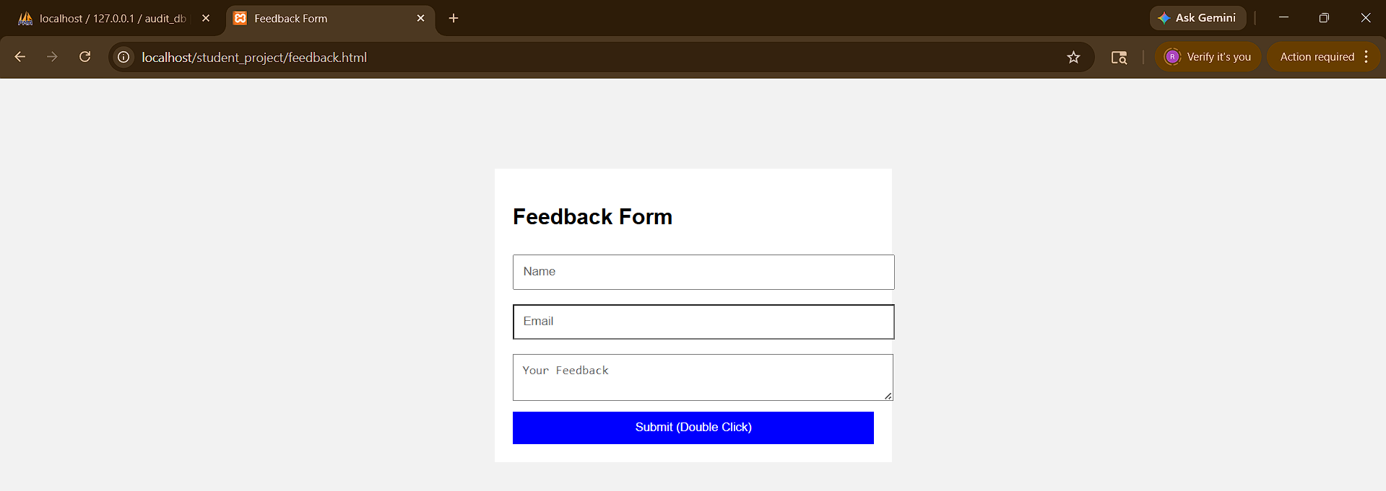

Result: Thus, the Interactive Web Form with Events & Functions was executed successfully and the output was generated.

